Light Sources
Every object in a scene is potentially a source of light. Light may be either or reflected from objects. Generally, in computer graphics we make a distinction between light emitters and light reflectors. The emitters are called light sources, and the reflectors are usually the objects being rendered. Light sources are characterized by their intensities while reflectors are characterized by their material properties.
Point Light Sources
The rays emitted from a point light radially diverge from the source. A point light source is a fair approximation to a local light source such as a light bulb. The direction of the light to each point on a surface changes when a point light source is used. Thus a normalized vector to the light emitter must be computed for each point that is illuminated.
Basic illumination models
Illumination models model the interaction of light with the surface and range from simple to very complex.

- Local Illumination = direct illumination - considers light traveling directly from source to surface

- Global Illumination = indirect illumination - takes into account reflection of light from other surfaces
Ambient Light

Even though an object in a scene is not directly lit it will still be visible. This is because light is reflected from nearby objects. Ambient light refers to any outside light such as sunlight coming through windows or overhead room light. i.e. Ambient light is the general background light all around us .Ambient light has no spatial or directional characteristics. The amount of ambient light incident on each object is a constant for all surfaces in the scene.

Let
Ia = Ambient light intensity
ka = Ambient light reflected

Then intensity on the surface is described by
I = Iaka

Ideal Diffuse Reflection
First, we will consider a particular type of surface called an ideal diffuse reflector. An ideal diffuse surface is, at the microscopic level, a very rough surface.
Chalk is a good approximation to an ideal diffuse surface.

Because of the microscopic variations in the surface, an incoming ray of light is equally likely to be reflected in any direction over the hemisphere. Ambient light reflection is an approximation of global diffuse lighting effects. Diffuse reflections are constant over each surface in a scene, independent of the viewing direction. The intensity of the diffuse reflection at any point is given by

I ambdiff = Kd Ia

where, Kd->Coefficient of diffused reflection.

Ia-> intensity of ambient light

Kd is assigned a constant value in the interval 0 to 1.

Lambert's cosine law

Ideal diffuse reflectors are also called Lambertian reflectors. Ideal diffuse reflectors reflect light according to Lambert's cosine law, (these are sometimes called Lambertian reflectors).

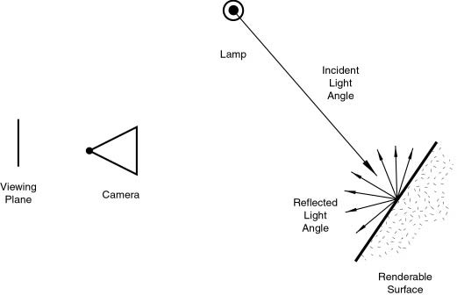
Lambert's law states that the reflected energy from a small surface area in a particular direction is proportional to the cosine of the angle between that direction and the surface normal. Lambert's law determines how much of the incoming light energy is reflected. The amount of energy that is reflected in any one direction is constant in this model. In other words, the reflected intensity is independent of the viewing direction. The intensity does, however, depend on the light source's orientation relative to the surface, and it is this property that is governed by Lambert's law.
If Il is the intensity of the point light source, then the diffuse reflection equation for a point on the surface can be written as
Il,diff = Kd Il cos θ
A surface is illuminated by a point source only if the angle of incidence is in the range 0 to 90 (cos θ is in the interval from 0 to 1).When cos θ is negative, the light source is behind the surface.
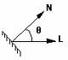
If N is the unit normal vector to a surface and L is the unit direction vector to the point light source from a position on the surface, then
Cos θ =N.L
The diffuse reflection equation for a point source illumination is
Il,diff = Kd Il (N.L)
According to Lambert’s cosine law the intensity of the reflected light depends on the angle of illumination. A surface that is perpendicular to the direction of the incident light appears brighter than a surface that is at an angle to the direction of the incoming light. As an angle increases less of the incident light falls on the surface.

We can combine the ambient and point source intensity calculations to obtain an expression for the total diffuse reflection.

Total diffuse reflection equation is given by

Idiff = Ka Ia + Kd Il (N.L)

Specular Reflection

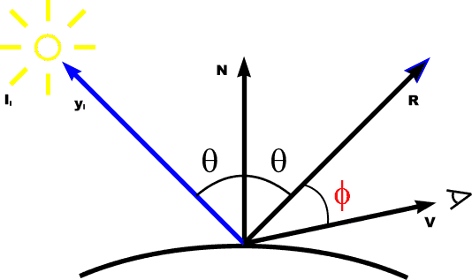

I spec = W(q) Il cos ns θ

Specular reflection, on the other hand, is viewpoint dependent. Light striking a specular surface, by Snell's Law, will be reflected at an angle which mirrors the incident light angle, so the viewing angle is very important. Specular reflection forms tight, bright highlights, making the surface appear glossy).
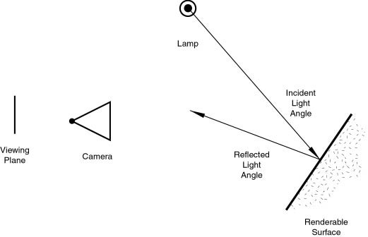

It is is the perfect, mirror-like reflection of light (or sometimes other kinds of wave) from a surface, in which light from a single incoming direction is reflected into a single outgoing direction. Such behaviour is described by the law of reflection, which states that the direction of outgoing reflected light and the direction of incoming light make the same angle with respect to the surface normal; this is commonly stated as θi = θr.

This is in contrast to diffuse reflection, where incoming light is reflected in a broad range of directions. The most familiar example of the distinction between specular and diffuse reflection would be matte and glossy paints. While both exhibit a combination of specular and diffuse reflection, matte paints has a higher proportion of diffuse reflection and glossy paints have a greater proportion of specular reflection. Very highly polished surfaces, such as high quality mirrors, can exhibit almost perfect specular reflection.

Even when a surface exhibits only specular reflection with no diffuse reflection, not all of the light is necessarily reflected. Some of the light may be absorbed by the materials. Additionally, depending on the type of material behind the surface, some of the light may be transmitted through the surface. For most interfaces between materials, the fraction of the light that is reflected increases with increasing angle of incidence θi. If the light is propagating in a material with a higher index of refraction than the material whose surface it strikes, then total internal reflection may occur.

Phong Model
This is an empirical model, which is not based on physics, but physical observation. Phong observed that for very shiny surfaces the specular highlight was small and the intensity fell off rapidly, while for duller surfaces it was larger and fell off more slowly. He decided to let the reflected intensity be a function of (cos α)^{n} with n >= 200 for a shiny surface and n small for a dull surface. For a perfect reflector n equals infinity, and for a piece of cardboard n equals 0 or 1. In the diagram below we can see how the function (cos α)^{n} behaves for different values of n.
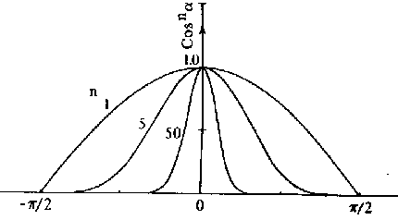
Specular reflection is also a function of the light incidence angle θ. An example is glass which has almost no specular reflectance for θ = 0 degrees but a very high specular reflectance for θ > 80 degrees. Some substances, such as copper, actually change color with change in the incidence angle, as shown in the following plot of the reflectance curve as a function of the incident angle for copper. .
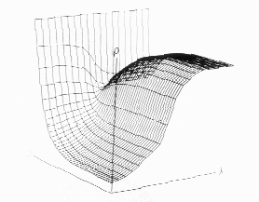

Warn model
- Simulates studio lighting effects by controlling light intensity in different directions
- control light direction using reflecting surface (only specular)
- control light direction using reflecting surface (only specular)

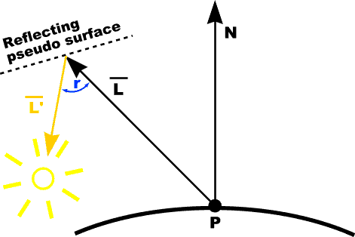

- Flaps are used to control the amount of light emitted by a source in various directions

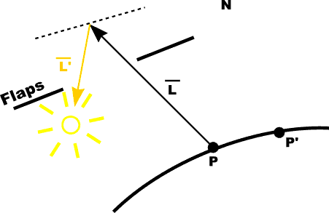
- Spot lighting is simulated in warn model

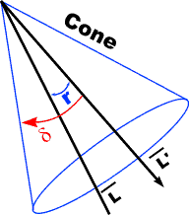

RGB color model

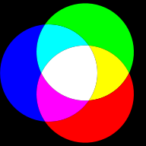

The RGB color model is an additive model in which red, green, and blue (often used in additive light models) are combined in various ways to reproduce other colors. The name of the model and the abbreviation ‘RGB’ comes from the three primary colors, red, green, and blue. These three colors should not be confused with the primary pigments of red, blue, and yellow, known in the art world as ‘primary colors’.

The RGB color model itself does not define what is meant by ‘red’, ‘green’ and ‘blue’, and the results of mixing them are not exact unless the exact spectral make-up of the red, green and blue primaries are defined. The color model then becomes an absolute color space, such as RGB or Adobe RGB; see RGB color space for more details. This article discusses concepts common to all the different RGB color spaces that use the RGB color model.

Rendering Methods
Constant Shading
The simplest shading model for a polygon is 'constant shading', also known as 'faceted shading' or 'flat shading'. This approach applies an illumination model once to determine a single intensity value that is then used to shade an entire polygon, and holding the value across the polygon to reconstruct the polygon's shade. This approach is valid if several assumptions are true:
- The light source is at infinity, so N.L is constant across the polygon face.
- The viewer is at infinity, so N.V is constant across the polygon face.
- The polygon represents the actual surface being modeled, and is not an approximation to a curved surface.
Gouraud Shading
'Gouraud shading also called intensity interpolation shading' or 'color interpolation shading', eliminates intensity discontinuities.
Gouraud shading extends the concept of interpolated shading applied to individual polygons by interpolating polygon vertex illumination values that take into account the surface being approximated. The Gouraud shading process requires that the normal {perpendicular vector} be known for each vertex of the polygonal mesh. Gouraud was able to compute these 'vertex normals' directly from an analytical description of the surface. Alternatively, if the vertex normals are not stored with the mesh and cannot be determined directly from the actual surface, then, Gouraud suggested, we can approximate them by averaging the surface normals of all polygonal facets sharing each vertex .If an edge is meant to be visible (as at the joint between a plane's wing and body), then we find two vertex normals, one for each side of the edge, by averaging the normals of polygons on each side of the edge separately.
The next step in Gouraud shading is to find 'vertex intensities' by using the vertex normals with any desired illumination model. Finally, each polygon is shaded by linear interpolation of vertex intensities along each edge and then between edges along each scan line .The term 'Gouraud shading' is often generalized to refer to intensity interpolation shading of even a single polygon in isolation, or to the interpolation of arbitrary colors associated with polygon vertices {as is the case in computer games}.
The algorithm can be stated is as follows:
- Compute a normal N for each vertex of the polygon.
- From N compute intensity I for each vertex of the polygon.
- From bi-linear interpolation compute intensity Ii for each pixel.
- Paint pixel to shade corresponding to Ii.
Phong Shading
The third shading model, Phong shading, is similar to Gouraud shading except that the Normals are interpolated. Thus, the specular highlights are computed much more precisely than in the Gouraud shading model.
The algorithm is as follows:
- Compute a normal N for each vertex of the polygon.
- From bi-linear interpolation compute a normal, Ni for each pixel. (This must be renormalized each time)
- From Ni compute intensity Ii for each pixel of the polygon.
- Paint pixel to shade corresponding to Ii.
Note that this method is much more computationally intensive than Gouraud shading:

Ray Tracing Method

Our goal is find the color of each point on the view window. We subdivide the view window into small squares, where each square corresponds to one pixel in the final image. If you want to create an image at the resolution of 640x400, you would break up the view window into a grid of 640 squares across and 400 square down. The real problem, then, is assigning a color to each square. This is what ray tracing does.

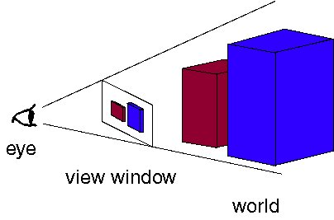

The objective is to determine the color of each light ray that strikes the view window before reaching the eye. Natural assumption would be that rays are traced starting at their point of origin, the light source, and towards their destination, the eye. Some will reach the eye directly, others will bounce around some and then reach the eye, and many, many more will probably never hit the eye at all. For all the rays that never reach the eye, the effort tracing them was wasted.

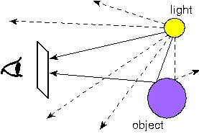

Fig:Tracing rays from the light source to the eye. Lots of rays are wasted because they never reach the eye.

In order to save ourselves this wasted effort, we trace only those rays that are guaranteed to hit the view window and reach the eye. It seems at first that it is impossible to know beforehand which rays reach the eye. After all, any given ray can bounce around the room many times before reaching the eye. However, if we look at the problem backwards, we see that it has a very simple solution. Instead of tracing the rays starting at the light source, we trace them backwards, starting at the eye. Consider any point on the view window whose color we're trying to determine. Its color is given by the color of the light ray that passes through that point on the view window and reaches the eye. We can just as well follow the ray backwards by starting at the eye and passing through the point on its way out into the scene. The two rays will be identical, except for their direction: if the original ray came directly from the light source, then the backwards ray will go directly to the light source. So the backwards method does the same thing as the original method, except it doesn't waste any effort on rays that never reach the eye.
This, then, is how ray tracing works in computer graphics. For each pixel on the view window, we define a ray that extends from the eye to that point. We follow this ray out into the scene and as it bounces off of different objects. The final color of the ray (and therefore of the corresponding pixel) is given by the colors of the objects hit by the ray as bit travels through the scene.
Just as in the light-source-to-eye method it might take a very large number of bounces before the ray ever hits the eye, in backwards method it might take many bounces before the ray every hits the light. Since we need to establish some limit on the number of bounces to follow the ray on, we make the following approximation: every time a ray hits an object, we follow a single new ray from the point of intersection directly towards the light source.
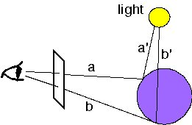
We trace a new ray from each ray-object intersection directly towards the light source
In the figure we see two rays, a and b, which intersect the purple sphere. To determine the color of a, we follow the new ray a' directly towards the light source. The color of a will then depend on several factors, discussed in Color and Shading below. As you can see, b will be shadowed because the ray b' towards the light source is blocked by the sphere itself. Ray a would have also been shadowed if another object blocked the ray a'.

